NAME: AROOBA QAISER

ROLL NO: 20011598-060

ADD STOCK MICROSERVICE

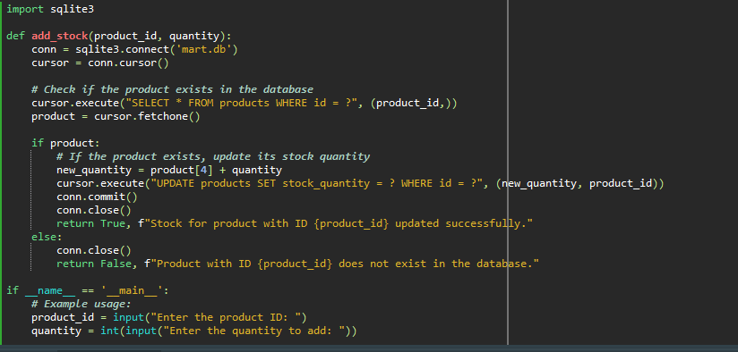

OUTPUT

